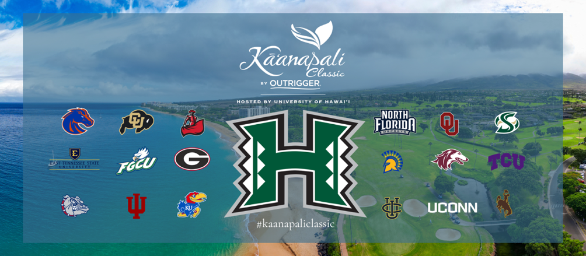

FOR IMMEDIATE RELEASE
October 27, 2025
MEDIA CONTACT
Pate Clarson
pclarson@kaanapaligolfcourses.com

Oklahoma establishes early first round lead in
2025 Kā‘anapali Classic by OUTRIGGER

OU’s Jase Summy finishes one shot shy of course record

LAHAINA, Hawai‘i – Overlooking Kā’anapali’s picturesque three-mile stretch of beaches "Where the World Comes to Play," the No. 21 ranked Oklahoma Sooners took an early four-shot lead in the opening round of the Kā‘anapali Classic by OUTRIGGER.

The three-time defending tournament champions set the pace by finishing at 21-under. TCU (-17) and North Florida (-12) follow closely in solo second and third, respectively. Florida Gulf Coast, Georgia, and Boise State are tied for fourth at 11-under.

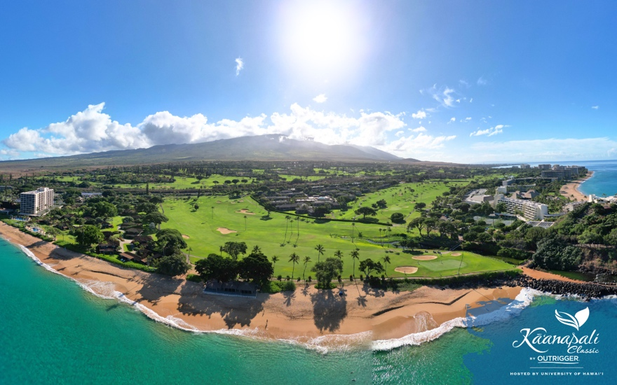
An aerial of Royal Kā‘anapali from high above the Pacific Ocean.

“As a team, we have really good ball hitters,” reflected Oklahoma senior Jase Summy. “You have to hit it well out here to score. Our team has relished that challenge each year on Maui.”

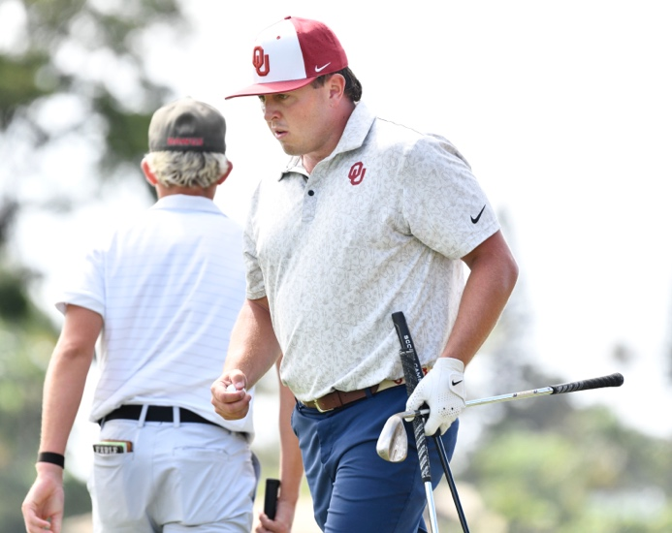
Oklahoma's Jase Summy fist pumps after his eagle on the par 5 ninth hole.

The Sooners have won a record five titles on Maui since the event’s inception in 2014. However, they seek their first team win of the 2025-26 season.

Oklahoma was anchored by three players who finished in the top 10 on Monday: Jase Summy (1), Ryder Cowan (2) and PJ Maybank III (T10). Competing as an individual, OU’s Asher Whitaker is 6-under (T3).

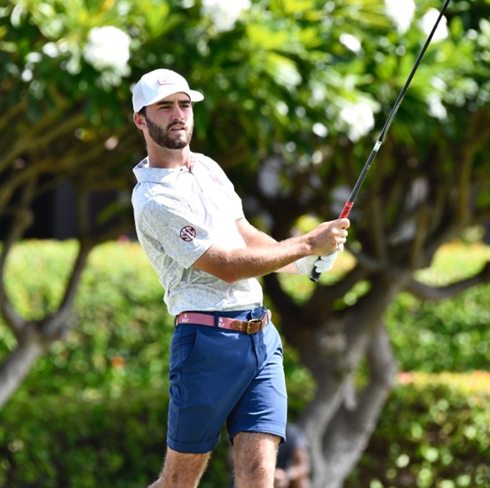
Oklahoma's Ryder Cowan eyes his tee shot on the 10th hole of Royal Kā‘anapali.

TCU returned four of the five players for the 2025-26 season who helped them reach the NCAA Regional last year. The Horned Frogs were also led by three players in the top 10: Sam Udovich (T3), Toby Wilt (T7) and Jack Beauchamp (T10).

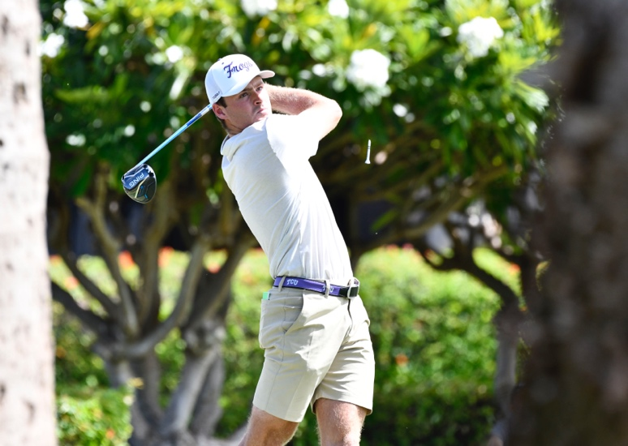
TCU's Jack Beauchamp observes his 10th hole drive on Royal Kā‘anapali.

North Florida, a perineal contender on Maui who qualified for the 2024 NCAA Men’s Golf Championship, trails closely. Flying highest for the Ospreys on Monday was Luke Balaskiewicz (T3).

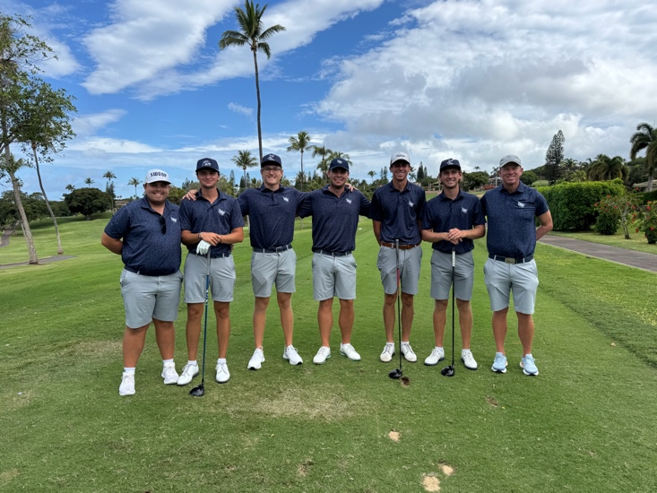
North Florida poses for a group photo on the hole 7 tee box of Royal Kā‘anapali.

Host Hawai‘i is tied for eight place without their highest ranked player, Josh Hayashida. The senior from O‘ahu is taking a medical redshirt after sustaining a back injury following his Manoa Cup win.

Maui's own Ansen Cabello and Chris Salem led the Rainbow Warriors with scores of 4-under and 3-under, respectively. Cabella graduated from Kamehameha Schools–Maui in 2023, and Salem from nearby Maui Prep in 2025.

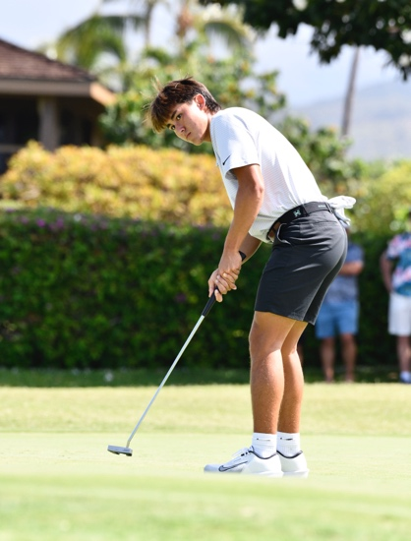
Hawai‘i's Chris Salem watches his birdie putt on hole 14 at Royal Kā‘anapali.

In a stacked Individual leaderboard, 23 players are within the top 10.

Oklahoma’s Summy’s 62 finished one stroke shy of the course record, set during Jim Colbert’s opening round of 61 en route to winning the Senior PGA Tour’s First Development Kā‘anapali Classic in 1991. This feat was also matched in 1998 by Jay Siegel.

“My prior visits here taught me how to make birdies when you need them most. Lots of guys are making them. You need to consistently hit good shots to create momentum,” noted Summy. “It’s also really cool to have the beach and mountains next to one another. We love playing here.”

Summy’s August win in the 123rd Western Amateur – the third oldest amateur championship in the world – places him amongst an esteemed list of past champions including Jack Nicklaus, Phil Mickelson and Tiger Woods.

North Florida’s Luke Balaskiewicz, a true freshman, carded a career-best 6-under 65.

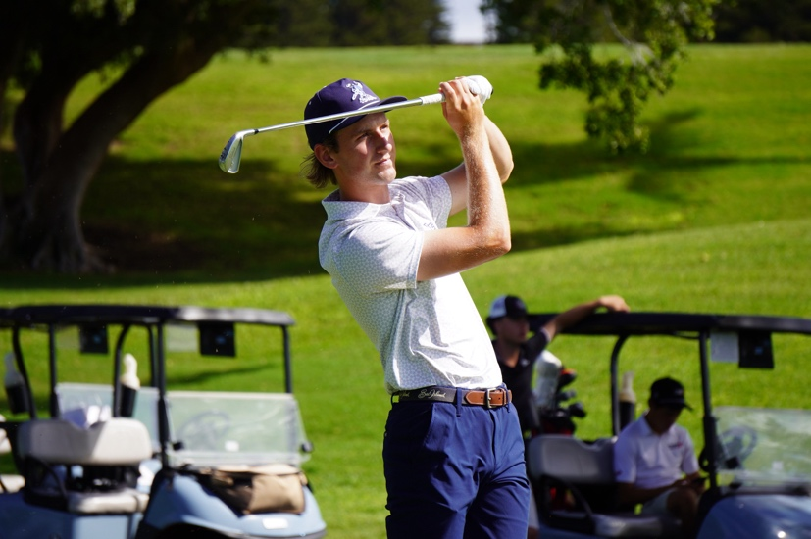
North Florida's Luke Balaskiewicz holds his finish on the par 3 15th hole

“The grasses felt similar to Florida, which gave me confidence on a familiar playing surface,” remarked Balaskiewicz. “Though I played great, I recognize that I got by with a lot. My wedges bailed me out. I’m looking to build upon hitting more greens tomorrow to alleviate that pressure.”

Fellow freshman Brett Moore of Florida Gulf Coast also sits T3 at 6-under. Moore recorded the lowest round in FGCU men’s golf history earlier this season in the SeaBest Invitational (Jacksonville, Fla.).

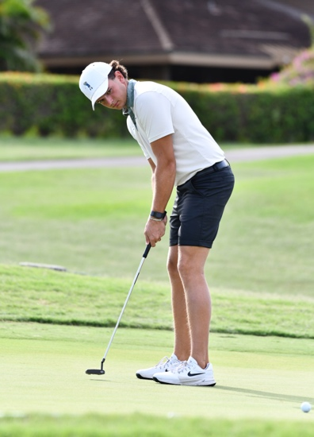
Florida Gulf Coast's Brett Moore observes his putt on the 9th hole.

“I got off to a great start today, 3-under through seven holes, but had to rely on my ball striking to get close enough to make par putts that kept my round going,” reminisced Moore. “Tomorrow, I’m looking to stay more patient.”

“This is my first time in Hawai‘i. I already love it,” continued Moore. “We jumped off Black Rock, saw the Nakalele Blowhole and look forward to spending time with my teammates on the beach.”

Following Tuesday’s round at 3 p.m., Hawai‘i men’s golf coach Scott Simpson and his team will host a clinic for the Maui Junior Golf Association and Lahaina Junior Golf Association students. Local children will be given special one-on-one access to learn about college recruiting, receive swing lessons and more.

The second round begins on Tuesday at 8:30 a.m. HST. Attendance is free for walking spectators. Parking is available on-site. Overflow parking is at nearby Whalers Village for a small fee.

All team and individual scores can be found here: SCOREBOARD

Team Leaderboard
Place | School | To Par | Rd. 1
1 | Oklahoma | -21 | 263
2 | TCU | -17 | 267
3 | North Florida | -12 | 272
T4 | Florida Gulf Coast | -11 | 273
T4 | Georgia | -11 | 273
T4 | Boise State | -11 | 273
7 | Southern Illinois | -9 | 275
T8 | Colorado | -8 | 276
T8 | Sacramento State | -8 | 276
T8 | San Jose State | -8 | 276
T8 | Gonzaga | -8 | 276
T8 | Hawai‘i | -8 | 276
13 | Indiana | -4 | 280
T14 | East Tennessee State | -3 | 281
T14 | Kansas | -3 | 281
T14 | Connecticut | -3 | 281
17 | Wyoming | +1 | 285
18 | UC Irvine | +4 | 288
19 | CSU Northridge | +7 | 291

Top Individuals
Place | Player | School | To Par | Rd. 1
1 | Jase Summy | Oklahoma | -9 | 62
2 | Ryder Cowan | Oklahoma | -7 | 64
T3 | Luke Balaskiewicz | North Florida | -6 | 65
T3 | Brett Moore | Florida Gulf Coast | -6 | 65
T3 | Sam Udovich | TCU | -6 | 65
T3 | *Asher Whitaker | Oklahoma | -6 | 65
T7 | Oliver Ulrich | Southern Illinois | -5 | 66
T7 | Ethan Flynn | Gonzaga | -5 | 66
T7 | Toby Wilt | TCU | -5 | 66
T10 | Jack Beauchamp | TCU | -4 | 67
T10 | *Kellen Ball | Wyoming | -4 | 67
T10 | Ty Holbrook | Colorado | -4 | 67
T10 | William Baker | Kansas | -4 | 67
T10 | Matt Moloney | Georgia | -4 | 67
T10 | Danny Erickson | North Florida | -4 | 67
T10 | Carter Loflin | Georgia | -4 | 67
T10 | Jayden Lizama | Gonzaga | -4 | 67
T10 | Gavyn Knight | Boise State | -4 | 67
T10 | Max Thomas | Sacramento State | -4 | 67
T10 | Avinash Iyer | San Jose State | -4 | 67
T10 | Ryan Meyer | Boise State | -4 | 67
T10 | PJ Maybank III | Oklahoma | -4 | 67
T10 | Anson Cabello | Hawai‘I | -4 | 67
*Competing as Individual

TOURNAMENT FACTS
Dates: Oct. 27–29, 2025
Format: 54 holes; 18 holes each day; 5-count-4
Time: 8:30 a.m. HST shotgun start each day
Venue: Kā‘anapali Golf Courses; Royal Kā‘anapali
Location: Lahaina, Maui
Yardage (Par): 6,700 (71)

###

About Kā’anapali Golf Courses
Built on 300 acres of land once home to Hawaiian royalty (Royal Chiefs of Maui), Kā‘anapali Golf Courses offers pristine conditions and panoramic views of Lana‘i, Molokai, the Pacific Ocean and West Maui Mountains.

Opened in 1962 and designed by Robert Trent Jones Sr., the par-71, 6,700-yard Royal Kā‘anapali Course features wide fairways and undulating greens which make it distinctive and demanding. The tournament-tested layout has welcomed Jack Nicklaus, Arnold Palmer, Greg Norman, Fred Couples, Jan Stephenson, Betsy King and other legends.

High-profile events have included Shell’s Wonderful World of Golf (1964), Canada Cup (1964), LPGA’s Kemper Open (1982-85), PGA TOUR Champions’ Kā‘anapali Classic (1987-2000) and SKINS Game (2008-11), and Hawaii High School Athletic Association Golf State Championships (1998, 2009, ’13, ’17, ’22).

Complementing Royal Kā‘anapali is the modernized Kai Course, which hosted Golf Channel’s “Big Break Kā‘anapali” in 2008. The 6,400-yard, par-70 layout boasts an array of strategically placed bunkers, contoured fairways and resurfaced greens.

More information: www.kaanapaligolfcourses.com and 808-661-3691.

About Troon
Kā‘anapali Golf Courses are managed by Indigo Sports, a Troon company. Headquartered in Scottsdale, Ariz., Troon is the world’s largest golf and golf-related hospitality management company providing services at 950-plus locations in 45-plus states and 40-plus countries, including operational responsibility for 575-plus 18-hole equivalent golf courses. In addition to golf, Troon specializes in homeowner association management, private residence clubs, estate management and associated hospitality venues. Troon’s award-winning food and beverage division operates and manages 600-plus food and beverage operations located at golf resorts, private clubs, daily fee golf courses and recreational facilities. Troon’s family of brands includes Troon Golf, Troon Privé, Troon International, Indigo Sports, CADDIEMASTER, ClubUp, Cliff Drysdale Tennis, Peter Burwash International, True Club Solutions, RealFood Hospitality, Strategy and Design, Casa Verde Golf, ICON Management and Eventive Sports. For additional news and information, visit www.Troon.com, TroonMagazine.com or connect with Troon on Facebook, X, and Instagram.

