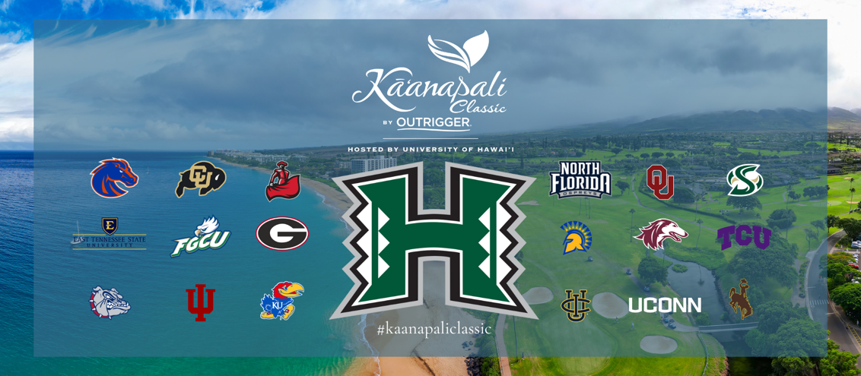

FOR IMMEDIATE RELEASE
October 29, 2025
MEDIA CONTACT
Pate Clarson
pclarson@kaanapaligolfcourses.com

Magic on Maui: Oklahoma breaks tournament scoring record to win fourth straight Kā‘anapali Classic by OUTRIGGER

Oklahoma’s Ryder Cowan edges TCU’s Sam Udovich to claim first title while tying individual tournament scoring record

LAHAINA, Hawai‘i – The University of Oklahoma men’s golf team delivered a historic performance in the 2025 Kā‘anapali Classic by OUTRIGGER, crushing the prior tournament scoring record by 11 shots to win their fourth consecutive team title on Maui.

The Sooners finished the three-day, 54-hole event with a blistering 63-under team total (789), breaking Kansas’ record of 800 held since 2021. The win is Oklahoma’s sixth Kā‘anapali Classic by OUTRIGGER title (2015, ’19, ’22, ’23, ’24, ‘25) since the event’s inception in 2014.

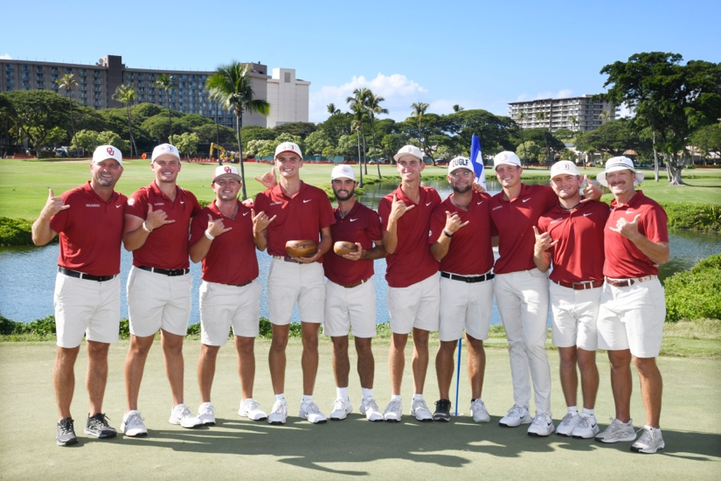
The Oklahoma Sooners celebrate their fourth consecutive Kā‘anapali Classic by OUTRIGGER team win and sixth overall on Oct. 29, 2025 in Lahaina, HI.

“We played difficult courses this fall where our guys couldn’t get birdies to drop,” remarked Oklahoma men’s golf coach, Ryan Hybl, an inductee into the 2024 Golf Coaches Association of America Hall of Fame. “Traveling to Hawai‘i provided a much needed mental reset. Coupled with almost no wind (which is highly unusual), great ball striking and solid putting at Kā‘anapali, our guys capitalized on the opportunity. We are humbled and excited to again take home the title.”

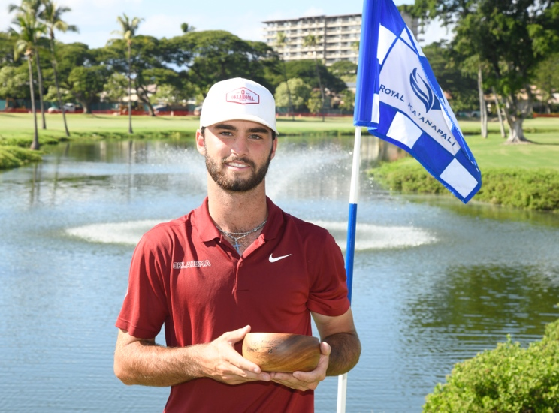
Oklahoma's Ryder Cowan enjoys his first collegiate win at the 2025 Kā‘anapali Classic by OUTRIGGER on Oct. 29, 2025 in Lahaina, HI.

Oklahoma’s victory further solidified their mastery of Royal Kā‘anapali. The Sooners concluded their fall season in historic fashion.

Leading the Sooners was Ryder Cowan. Cowan’s first individual collegiate title was earned with a score of 20-under (193). The junior from Edmond, Okla. and 2024-25 GCAA All-American kept his poise under pressure by holding off TCU’s Ryder Cowan on the final hole.

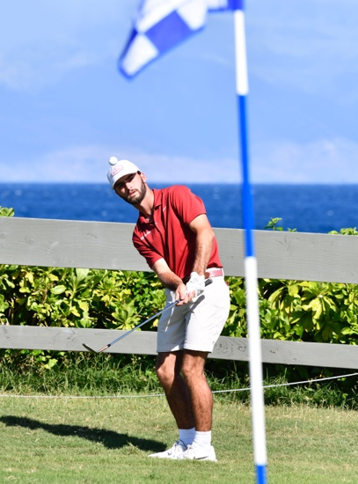
Oklahoma's Ryder Cowan eyes his greenside chip on the picturesque fifth hole during the final round of the 2025 Kā‘anapali Classic by OUTRIGGER on Oct. 29, 2025 in Lahaina, HI.

Cowan is now just one of three Sooners to ever post a 20-under mark, along with Chris Gotterup and Quade Cummings. His 2025 score also tied the Kā‘anapali Classic by OUTRIGGER individual scoring record set by Georgia’s Trent Phillips and Cummings in 2019.

The Sooners were anchored by three players who finished in the top seven of the 120-player field: Cowan (1), Jase Summy (3), and Clark Van Gaalen.

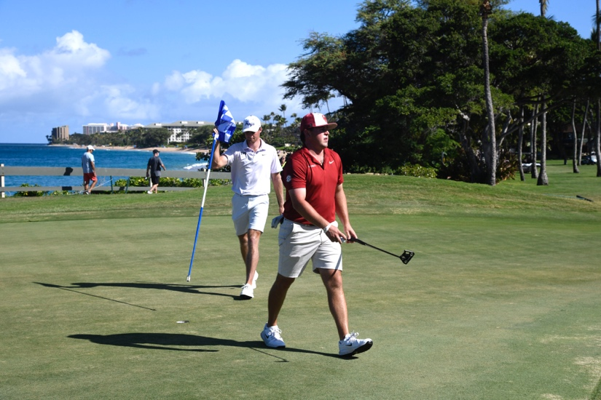
Oklahoma's Jase Summy walks away with par on the 5th hole during the final round of the 2025 Kā‘anapali Classic by OUTRIGGER on Oct. 29, 2025 in Lahaina, HI.

Summy, winner of the prestigious 2025 Western Amateur, now has three top-10 finishes on Maui, including another third place in 2024 and T8 in 2023.

After a runner-up finish last year as a true freshman, Van Gaalen notched another top-10 performance in 2025, securing seventh place at Kā‘anapali.

TCU (-51) secured second place. 51-under is the best TCU team score since at least the 1993-94 season. TCU was fueled by Sam Udovich (2), Jack Beauchamp (T7), and Toby Wilt (T11).

Udovich, a true freshman from Grove Heights, Minn. who was named Mr. Minnesota Golf in 2025, selected the Ft. Worth program after claiming multiple AJGA titles. His 19-under performance for 54 holes was the best by a Horned Frog since 2019.

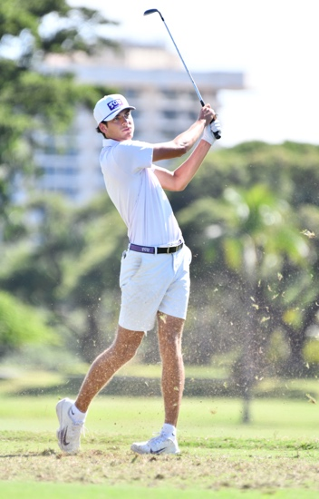
TCU's Sam Udovich observes his approach shot on the 6th hole during the final round of the 2025 Kā‘anapali Classic by OUTRIGGER on Oct. 29, 2025 in Lahaina, HI.

Beauchamp has finished in seventh place at Kā‘anapali in back-to-back seasons.

Georgia posted their second-best tournament score in program history at 47-under to finish in third place.

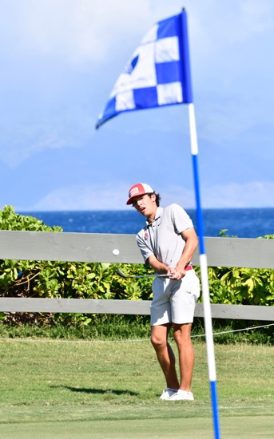
Georgia's JD Culbreth watches his greenside chip on the picturesque fifth hole during the final round of the 2025 Kā‘anapali Classic by OUTRIGGER on Oct. 29, 2025 in Lahaina, HI.

Florida Gulf Coast (-40), Colorado (-37), San Jose State (-33), Kansas (-27) and Southern Illinois (-25) finished in fourth through ninth place, respectively.

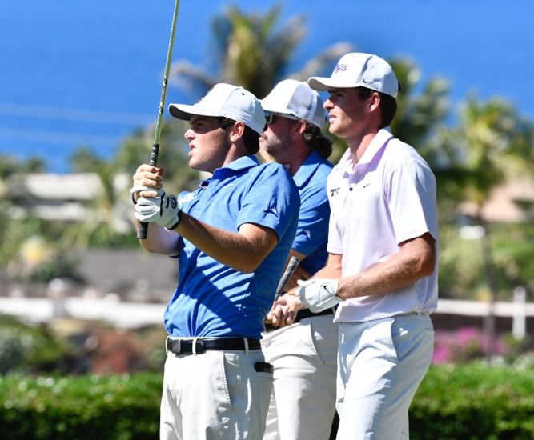
Florida Gulf Coast's Nolan Harper (left) eyes his tee shot as TCU's Toby Wilt watches during the final round of the 2025 Kā‘anapali Classic by OUTRIGGER on Oct. 29, 2025 in Lahaina, HI.

Other notables:
- Indiana’s Bradley Chill, Jr., recorded a hole-in-one on the par 3 15th hole
- Host Hawai‘i’s Anson Cabello was the highest-ranked Rainbow Warrior at T14
- Royal Kā‘anapali’s 18th hole, playing as a par 4 this week, was the number one handicap hole with a 4.51 average

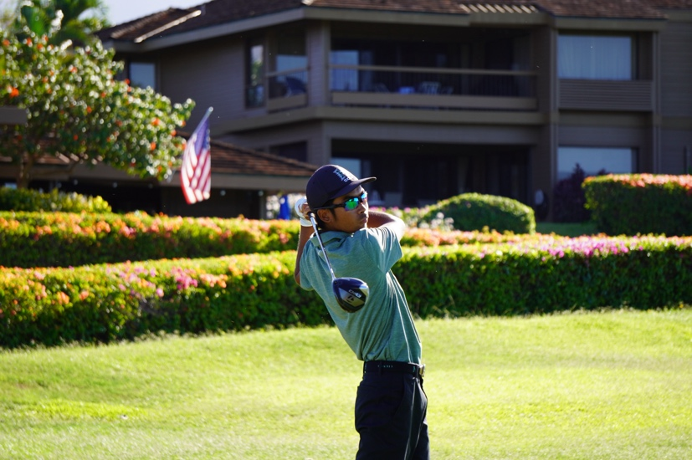
Hawai‘i's Anson Cabello tees off on hole 10 during the final round of the 2025 Kā‘anapali Classic by OUTRIGGER on Oct. 29, 2025 in Lahaina, HI.

The 12th annual Kā‘anapali Classic by OUTRIGGER will be contested from Oct. 26-28, 2026.

All team and individual scores can be found here: SCOREBOARD

Team Leaderboard
Place | School | To Par | Rd. 1 | Rd. 2 | Rd. 3 | Total
1 | Oklahoma | -63 | -21 | -26 | -16 | 789
2 | TCU | -51 | -17 | -18 | -16 | 801
3 | Georgia | -47 | -11 | -21 | -15 | 805
4 | Florida Gulf Coast | -40 | -11 | -17 | -12 | 812
5 | Colorado | -37 | -8 | -18 | -11 | 815
6 | San Jose State | -33 | -8 | -15 | -10 | 819
7 | Kansas | -27 | -3 | -15 | -9 | 825
8 | Southern Illinois | -25 | -9 | -9 | -7 | 827
T9 | North Florida | -24 | -12 | -10 | -2 | 828
T9 | East Tennessee State | -24 | -3 | -8 | -13 | 828
11 | Connecticut | -19 | -3 | -9 | -7 | 833
12 | Boise State | -15 | -11 | +1 | -5 | 837
T13 | Gonzaga | -10 | -8 | +4 | -6 | 842
T13 | Wyoming | -10 | +1 | -17 | +6 | 842
15 | Indiana | -9 | -4 | -10 | +5 | 843
T16 | Sacramento State | -4 | -8 | +4 | E | 848
T16 | Hawai‘i | -4 | -8 | -2 | +6 | 848
18 | CSU Northridge | +20 | +7 | -6 | +19 | 872
19 | UC Irvine | +23 | +4 | +2 | +17 | 875

Top Individuals
Place | Player | School | To Par | Rd. 1 | Rd. 2 | Rd. 3 | Total
1 | Ryder Cowan | Oklahoma | -20 | -7 | -9 | -4 | 193
2 | Sam Udovich | TCU | -19 | -6 | -7 | -6 | 194
3 | Jase Summy | Oklahoma | -18 | -9 | -4 | -5 | 195
4 | Nolan Harper | Florida Gulf Coast | -16 | -1 | -8 | -7 | 197
T5 | William King | Kansas | -14 | -3 | -6 | -5 | 199
T5 | Avinash Iyer | San Jose State | -14 | -4 | -4 | -6 | 199
T7 | Jack Beauchamp | TCU | -13 | -4 | -5 | -4 | 200
T7 | Carter Loflin | Georgia | -13 | -4 | -4 | -5 | 200
T7 | Clark Van Gaalen | Oklahoma | -13 | E | -7 | -6 | 200
T7 | JD Culbreth | Georgia | -13 | -1 | -10 | -2 | 200
T11 | Toby Wilt | TCU | -12 | -5 | -3 | -4 | 201
T11 | Matt Moloney | Georgia | -12 | -4 | -4 | -4 | 201
13 | Ivan Barahona | San Jose State | -11 | -1 | -5 | -5 | 202
T14 | Hunter Swanson | Colorado | -10 | -1 | -7 | -2 | 203
T14 | Ty Holbrook | Colorado | -10 | -4 | E | -6 | 203
T14 | PJ Maybank III | Oklahoma | -10 | -4 | -6 | E | 203
T14 | Anson Cabello | Hawai‘i | -10 | -4 | -4 | -2 | 203
*Competing as Individual

TOURNAMENT FACTS
Dates: Oct. 27–29, 2025
Format: 54 holes; 18 holes each day; 5-count-4
Time: 8:30 a.m. HST shotgun start each day
Venue: Kā‘anapali Golf Courses; Royal Kā‘anapali
Location: Lahaina, Maui
Yardage (Par): 6,700 (71)

###

About Kā’anapali Golf Courses
Built on 300 acres of land once home to Hawaiian royalty (Royal Chiefs of Maui), Kā‘anapali Golf Courses offers pristine conditions and panoramic views of Lana‘i, Molokai, the Pacific Ocean and West Maui Mountains.

Opened in 1962 and designed by Robert Trent Jones Sr., the par-71, 6,700-yard Royal Kā‘anapali Course features wide fairways and undulating greens which make it distinctive and demanding. The tournament-tested layout has welcomed Jack Nicklaus, Arnold Palmer, Greg Norman, Fred Couples, Jan Stephenson, Betsy King and other legends.

High-profile events have included Shell’s Wonderful World of Golf (1964), Canada Cup (1964), LPGA’s Kemper Open (1982-85), PGA TOUR Champions’ Kā‘anapali Classic (1987-2000) and SKINS Game (2008-11), and Hawaii High School Athletic Association Golf State Championships (1998, 2009, ’13, ’17, ’22).

Complementing Royal Kā‘anapali is the modernized Kai Course, which hosted Golf Channel’s “Big Break Kā‘anapali” in 2008. The 6,400-yard, par-70 layout boasts an array of strategically placed bunkers, contoured fairways and resurfaced greens.

More information: www.kaanapaligolfcourses.com and 808-661-3691.

About Troon
Kā‘anapali Golf Courses are managed by Indigo Sports, a Troon company. Headquartered in Scottsdale, Ariz., Troon is the world’s largest golf and golf-related hospitality management company providing services at 950-plus locations in 45-plus states and 40-plus countries, including operational responsibility for 575-plus 18-hole equivalent golf courses. In addition to golf, Troon specializes in homeowner association management, private residence clubs, estate management and associated hospitality venues. Troon’s award-winning food and beverage division operates and manages 600-plus food and beverage operations located at golf resorts, private clubs, daily fee golf courses and recreational facilities. Troon’s family of brands includes Troon Golf, Troon Privé, Troon International, Indigo Sports, CADDIEMASTER, ClubUp, Cliff Drysdale Tennis, Peter Burwash International, True Club Solutions, RealFood Hospitality, Strategy and Design, Casa Verde Golf, ICON Management and Eventive Sports. For additional news and information, visit www.Troon.com, TroonMagazine.com or connect with Troon on Facebook, X, and Instagram.

